# ­Updated 2021-09-20 11:50:56

# Open issues

* How to treat cases where midpiece-tail unclear? Note it down and try finding another sperm?
* How to decided where part ends if the part is (or adjacent parts are) glowing?
* Other?

# Before starting

**DOWNLOAD**

**-** file manager like freeCommander, fman helpful, but not necessary

- **GIMP**

- **Photoscape** X

- **SpermSizer** from [GitHub](https://github.com/wyrli/sperm-sizer), read the instructions there and **before starting** for the first time, copy the modified [config.ini](https://www.dropbox.com/s/p9jziw1qdg31cdk/config.ini?dl=0) into the folder with the program’s .exe file or simply modify the config.ini file so that its variables have the following values:

MarkerColor=#FF0000

MarkerSize=3

LineColors=#FFFFFF

LineThickness=2

Labels=Pixels

LabelColor=#000000

LabelSize=22

LineSmoothing=4

SnapEnabled=true

TrimRadius=8

CropPadding=100

CompressCroppedImages=true

**HELPFUL INFO:**

**SpermSizer** uses the following **control keys**



**SpermSizer can show modified image**. If you modify the original picture (that is already loaded in SpermSizer) and save it with the same name (overwrite it), the modified image will not show, but if you click on a different image in SpermSizer and then again on the “newly” loaded one (that has the same name as the initial one), the modified picture will appear. The Measuring protocol (below) makes use of this feature when dirt or unclear background disturbs the measurements.

**Shortcuts for GIMP:** Save and overwrite and image – **assign this shortcut** by going to Edit -> Keyboard shortcuts (on Mac to GIMP-2 -> Keyboard shortcuts), typing overwrite in the search box, placing a cursor in the shortcut field and press ctrl+o, Close.

Save as – on mac Shift + command + E, on PC TO FIND OUT

# Choose sperm for SpermSizer measurements

(a) It is best to use images with a clean background, with a single sperm (or other sperm far away), and a sperm cell that is +/- straight and not glowing much (see test image 38 - ruff 1386 2021-07-12 Snap-1509.jpg - below)

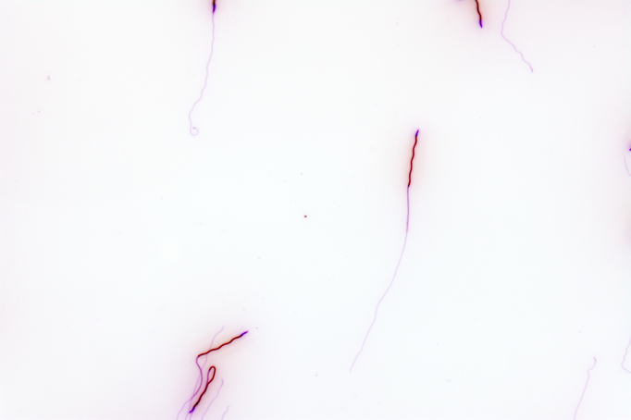

Example of poor images (glowing, with colorful background and those where sperm cells are close to each other):

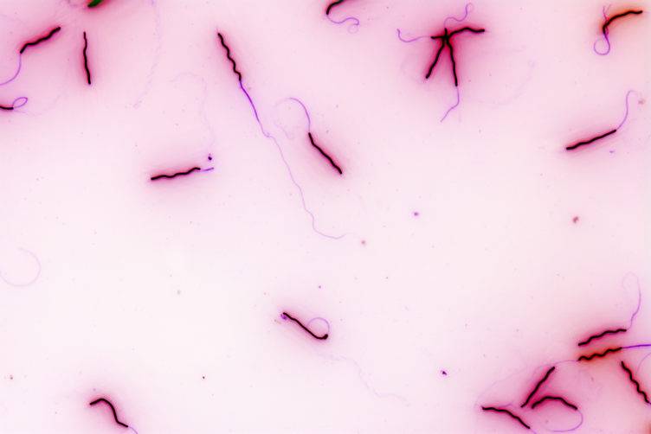 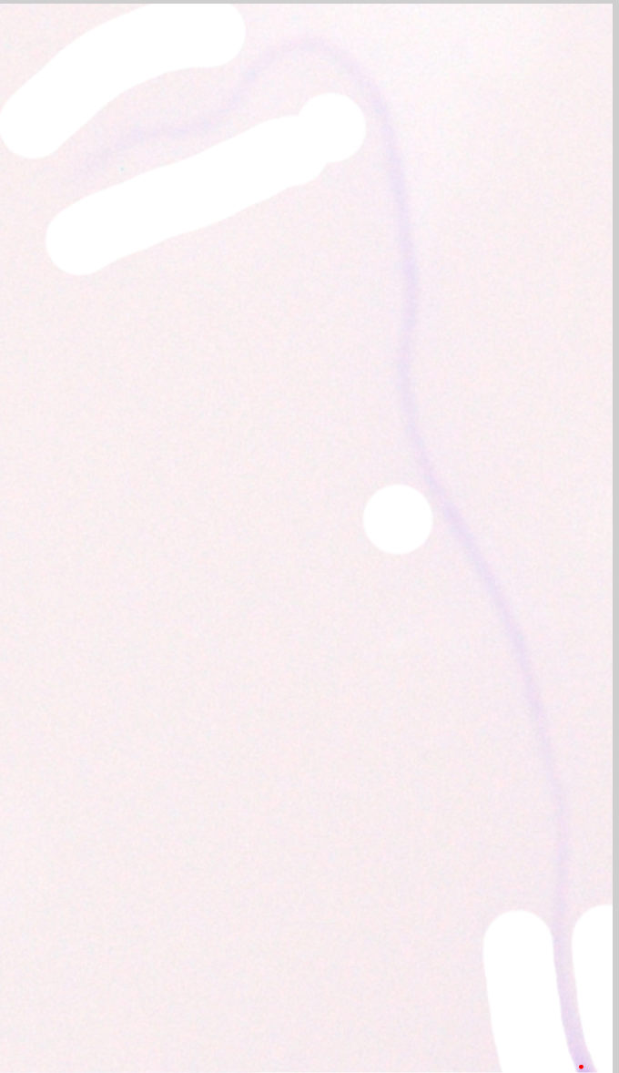 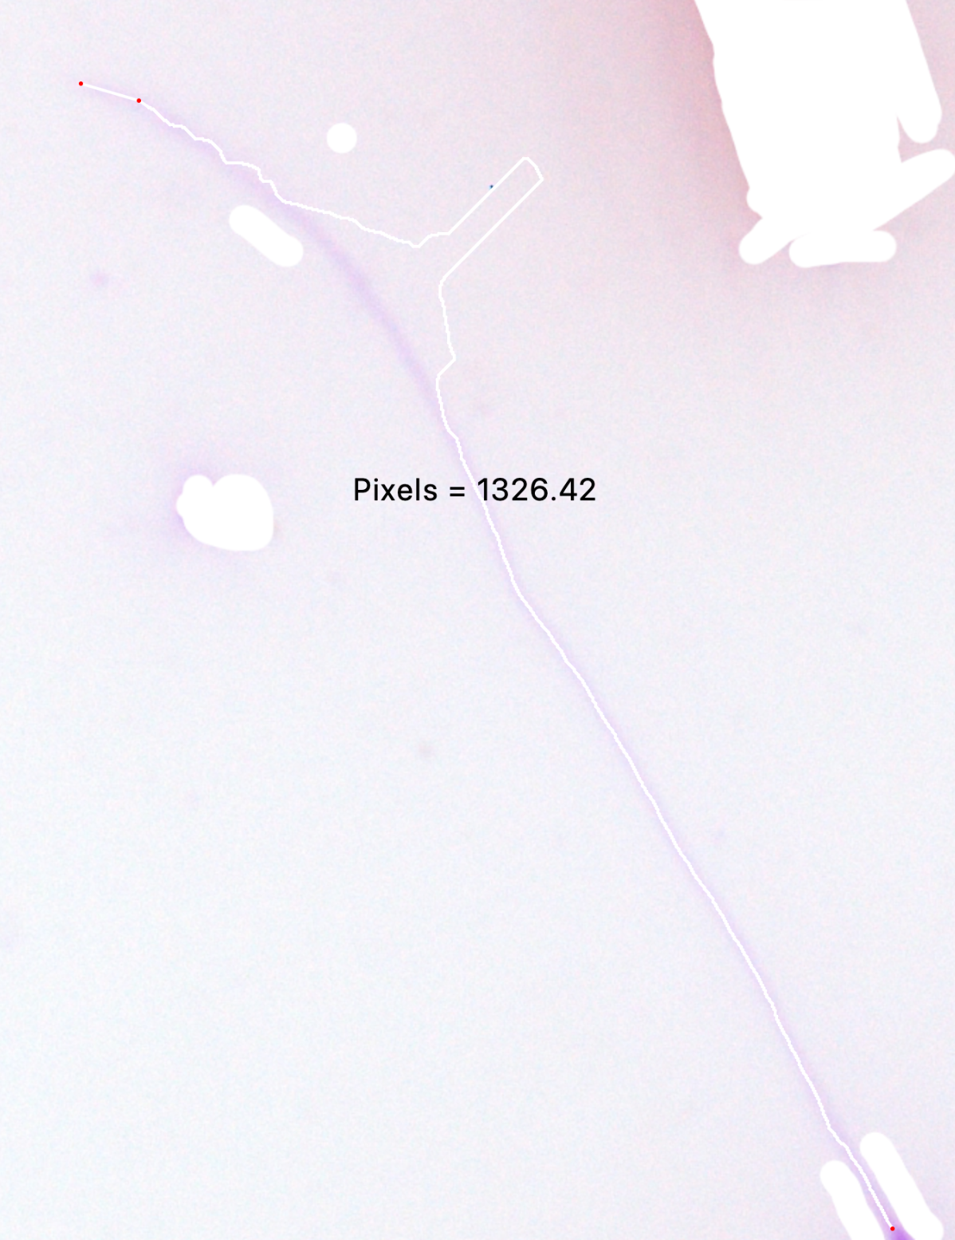

(b) If plenty of sperm is available for a given male, use the best (see a-b) and ideally where tail and midpiece are distinguishable.

(c) If more sperm cells are on one image, cut single sperm cells out so that you can measure those on separate images because that is the only way to attribute each part of the sperm to a specific sperm cell. The cutting out of the sperm can be done in GIMP using Rectangle select tool, selecting the cell and cropping to selection by right clicking, choosing Image and Crop to selection, pressing shift + command + E on mac (ADD FOR PC) or going to Export and export the image while adding ‘a’ to the end of ist name. do the same for the other sperm cells on the picture naming those b, c, d, etc..

# Prepare images for SpermSizer measurements

All original pictures, renamed with randomly assigned number are in the folder ‘renamed’ and create here a subfolder ‘inverted’ and ‘measuring’.

**Inverting**

Open Photoscape X, go to Batch edit and drag and drop all the pictures you wish to invert.

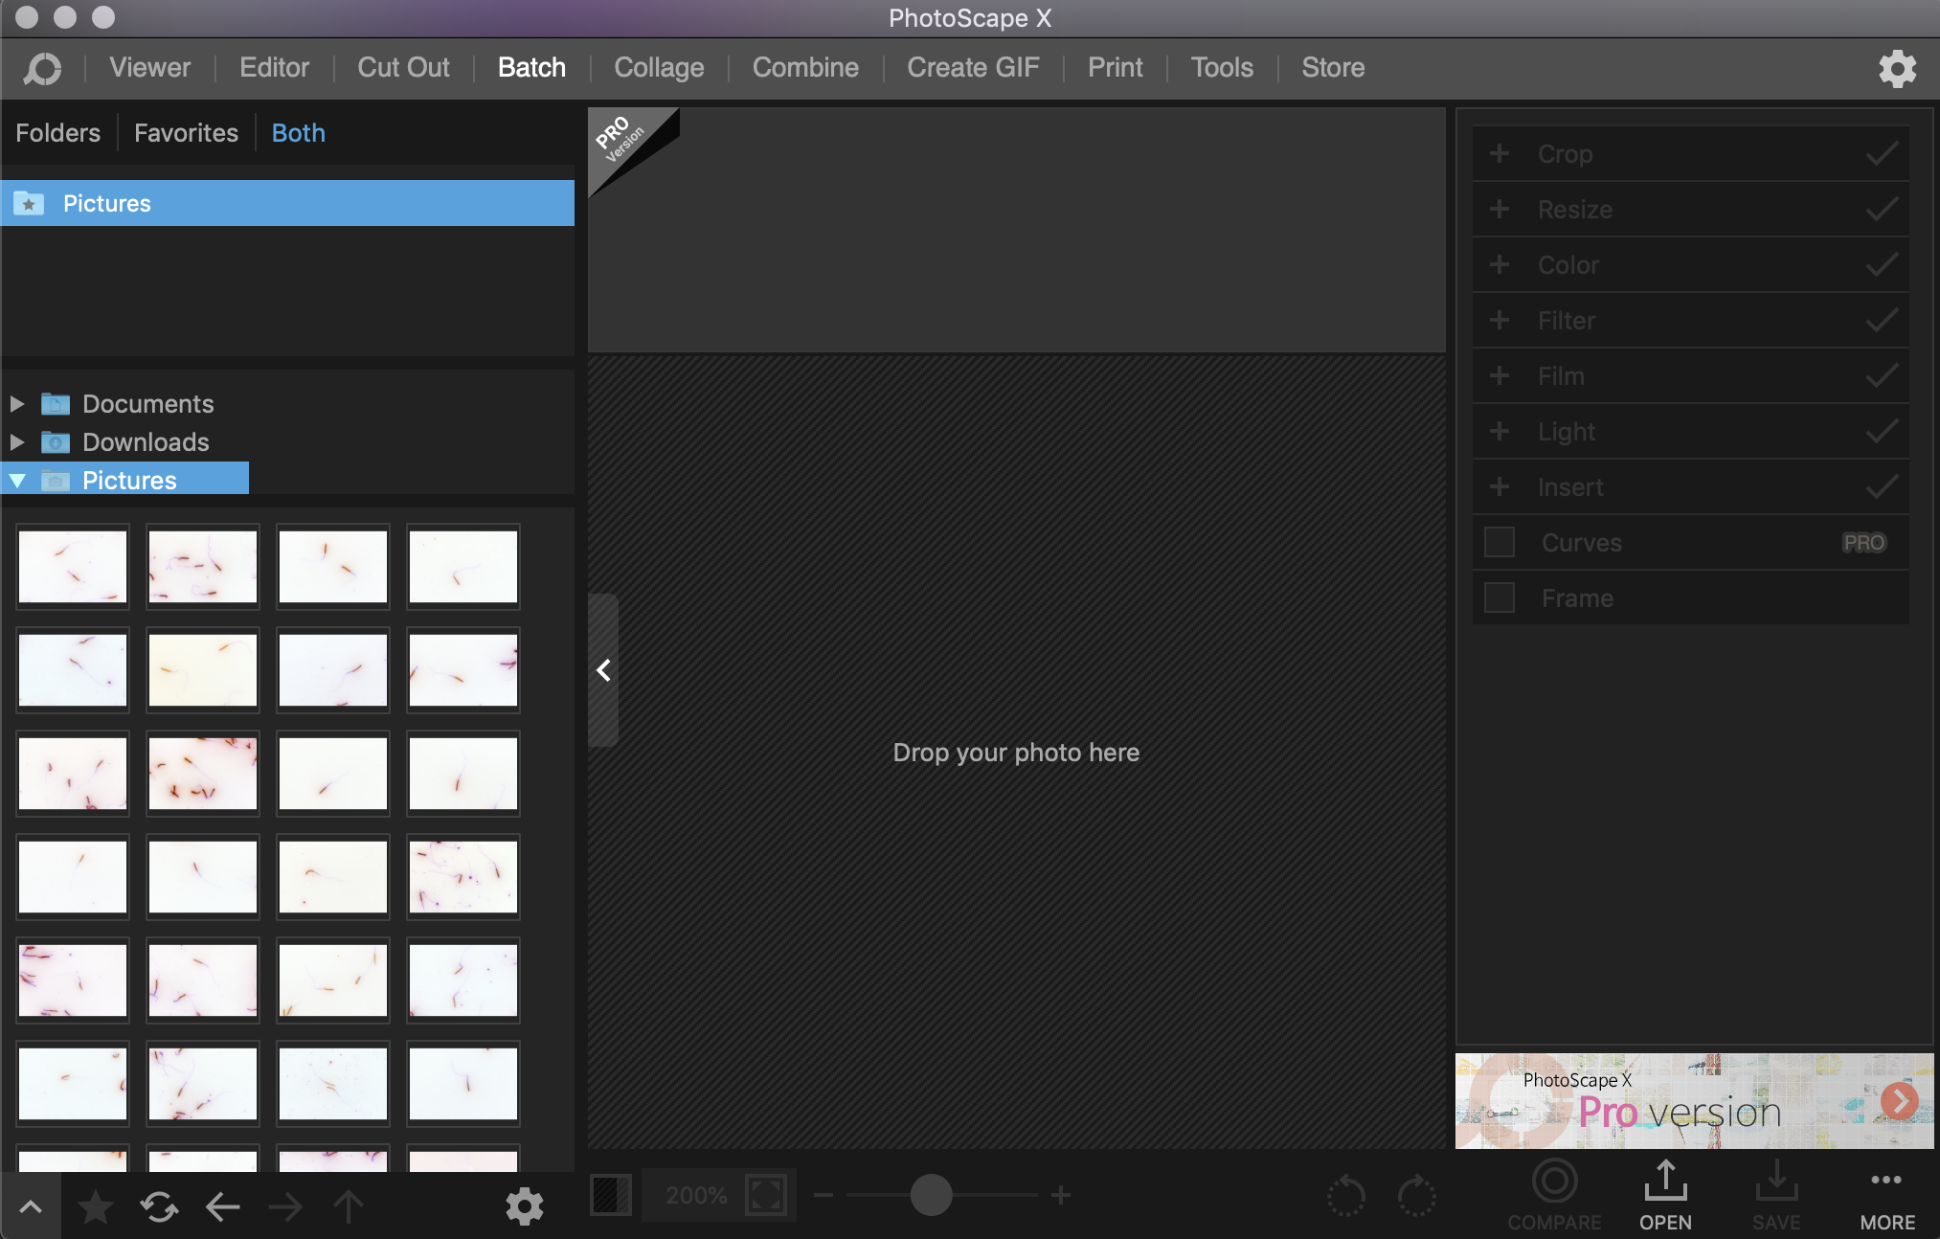

Go to ‘Color’ tab on the right and tick the box next to negative.

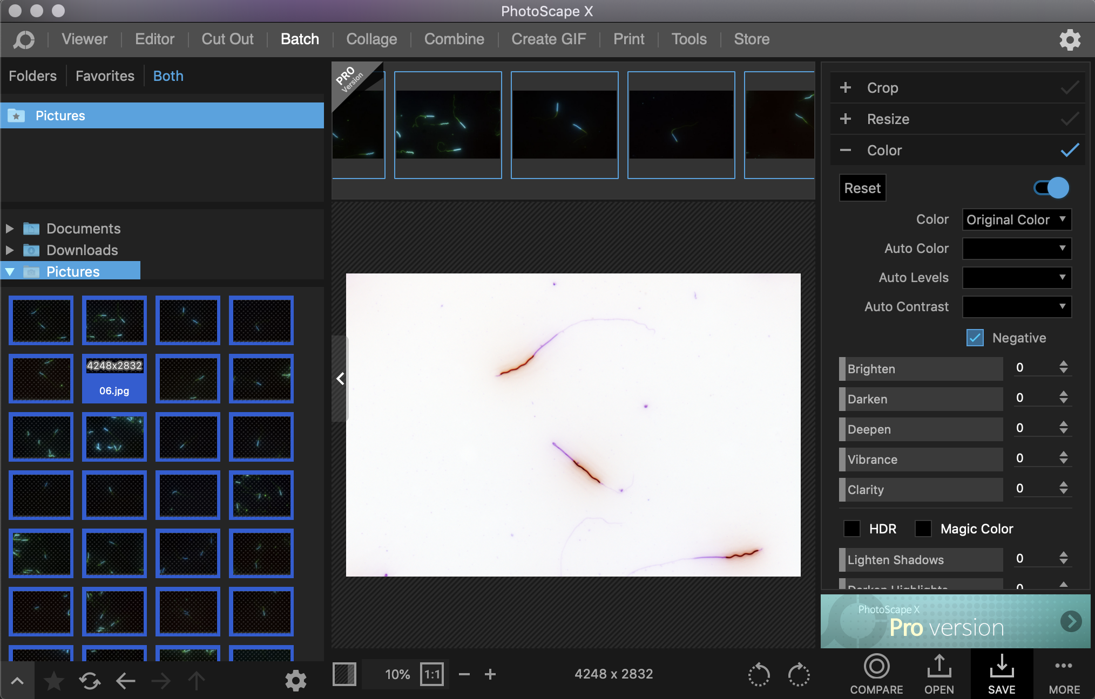

Press ‘SAVE’. Choose JPEG Quality 100, subfolder ‘inverted’, Suffix ‘_inv’ and press OK. Then copy the images from inverted folder to measuring folder.

# Measure the sperm with SpermSizer

**LOADING IMAGES**

Once the program is on, **add** as many **images** as you want to measure to the Sperm Sizer.

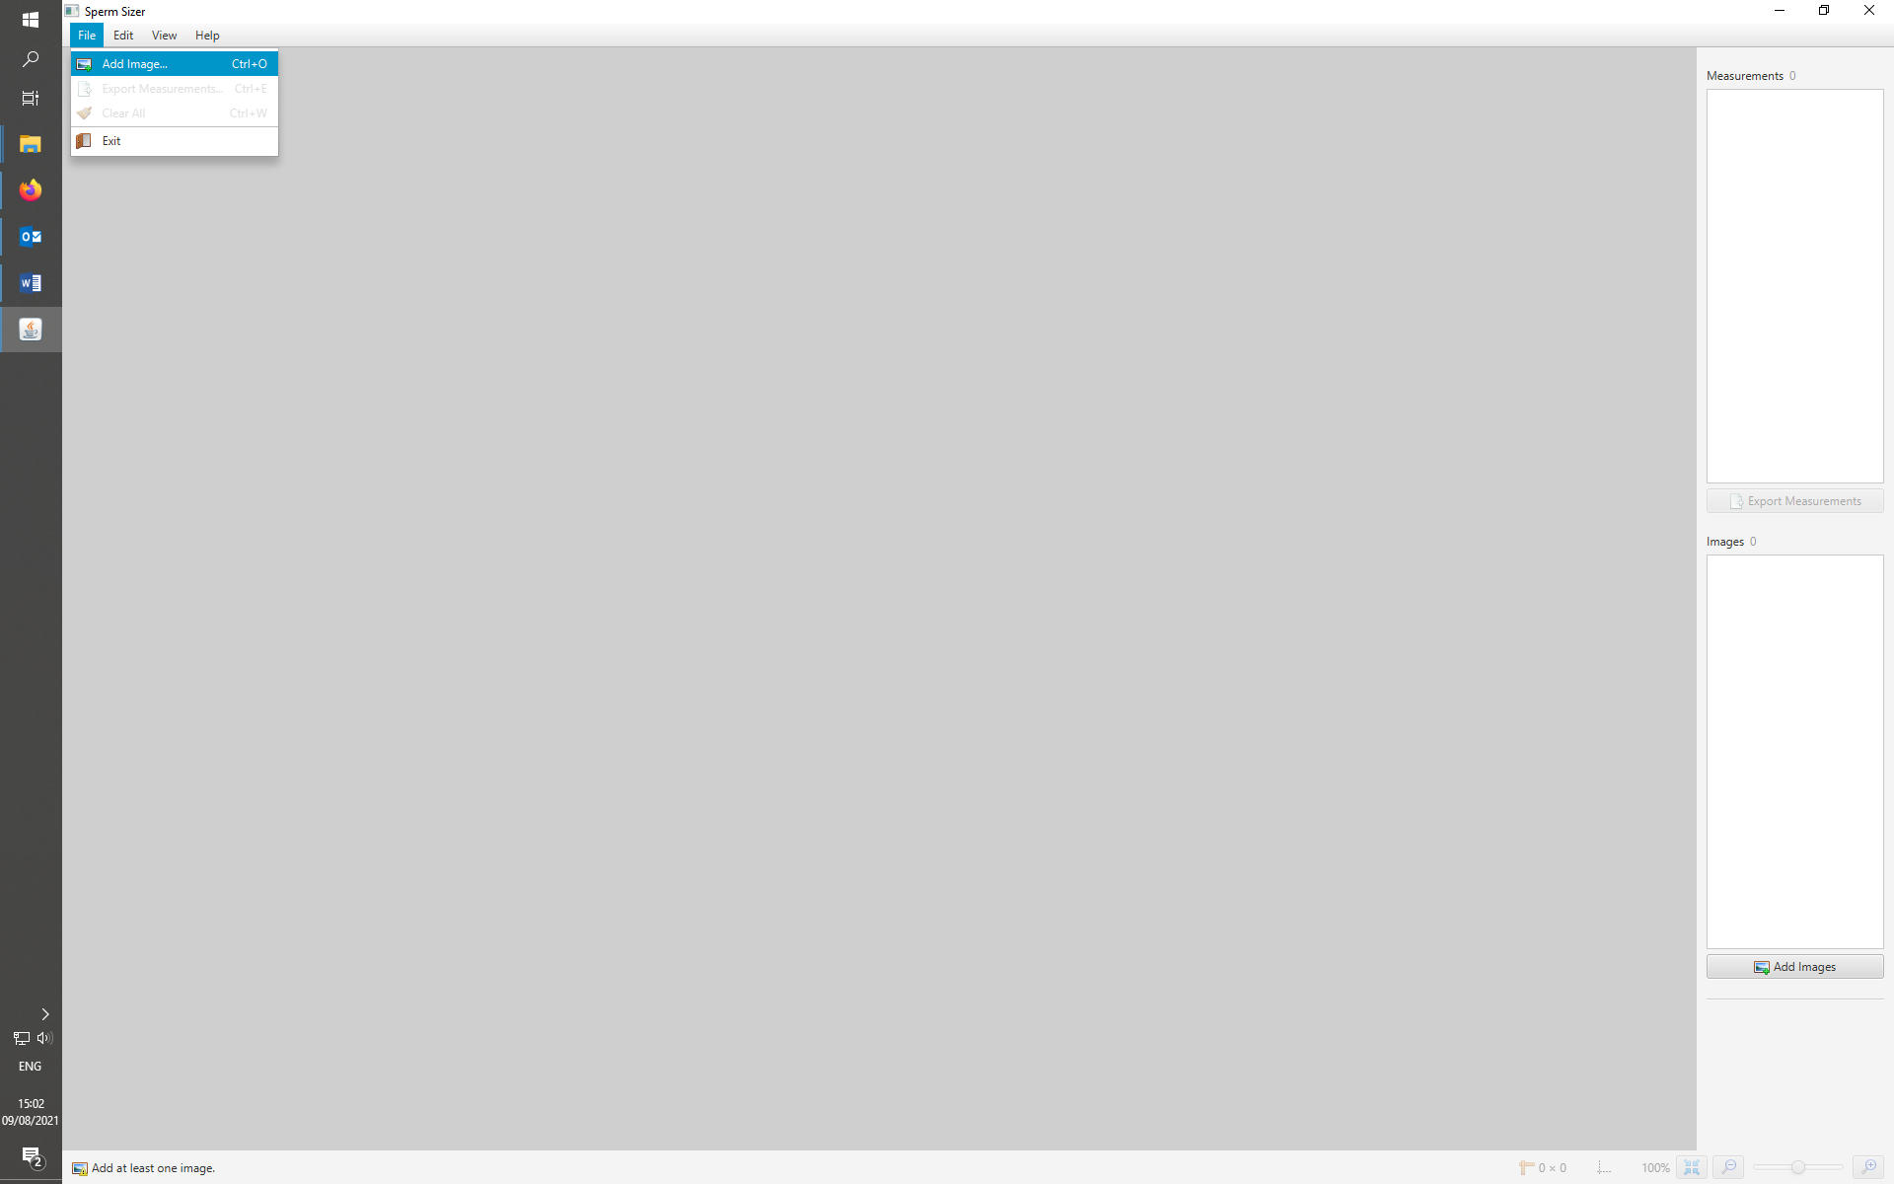

**MEASUREMENTS**

Each part of the sperm is measured separately and is enclosed by the two dots you place on the sperm. The program calculates the distance in pixels as soon as you place the second dot. If the acrosome line is faded at the start, you can help SpermSizer by dragging a line from the faded start until the acrosome is easier to see and then making the dot where the acrosome ends (see GitHub [example](https://github.com/wyrli/sperm-sizer#straight-line-extensions) of this straight line extension). Same can be done with the faded tail, but in a reverse order, i.e. you place a dot where the tail starts and then drag the line from where the tail is clear until the end where it fads.

It is essential to keep the order of the measurements: Acrosome, Nucleus, Midpiece, Tail.

**IN CASE A MEASUREMENT (usually of tail) FAILS or PROGRAM TRACKS A PART WRONGLY**

It can happen that the tail fails to be picked by the Sperm Sizer program, or that a big object adjacent to the sperm, which could be another sperm or some background dirt, induces the program to create a wrong outline of the shape of the sperm. In those cases, undo the last point defining the end of the Tail and try again (even several times). If the tries fail, click on a previous image in SpermSizer and then open the image of interest in GIMP. Choose Eraser Tool set the Size to 200 and erase the area around the tail (for fine details – if needed – use eraser Size 20-50). You may need to zoom in with + (or mouse; on mac hold Command and use trackpad).

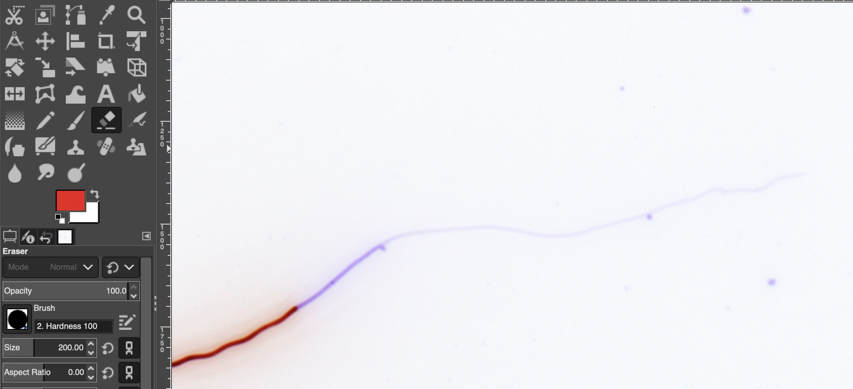

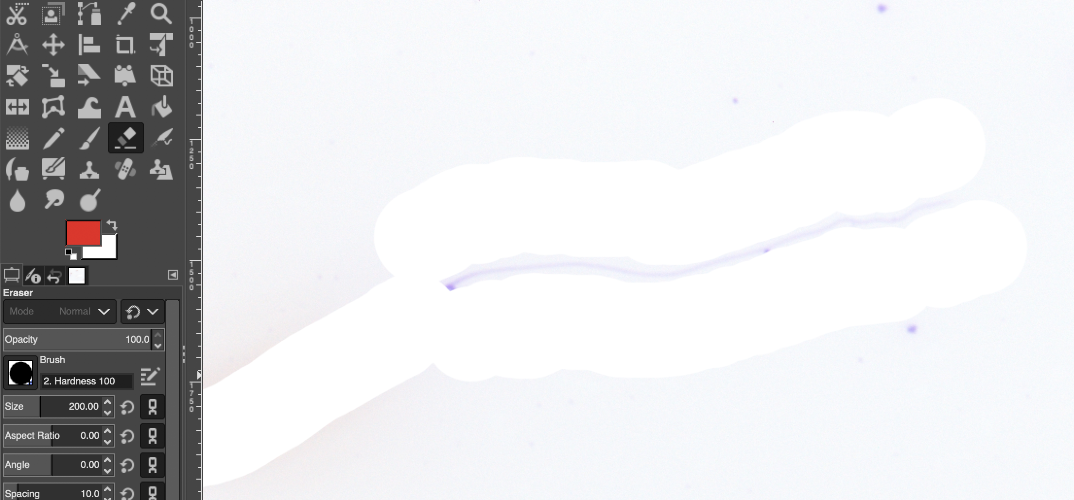

Once done, press ctrl+o, you will be prompted to overwrite the image which you confirm. Go back to SpermSizer click on the image of interest and the erased image will be loaded while your measurements of previous parts remain intact. Place the dot where the Tail ends and Tail will be measured. Press on a previous image, then return to GIMP and press export (or use shortcut – on mac shift+command+E) to export the modified image. Save it with ‘_era’ suffix, which will allow us to backtrack, which images were measured on modified images and if needed to identify the actual modified image. Then copy the same image from Inverted folder to Measuring folder. This will overwrite the erased image with the original one, so that the SpermSizer exported pictures show the actual sperm and not the erased parts. Go to SpermSizer, click on the image you have just measured and the original picture will appear. Continue with the next image.

Albeit in the above example, the whole area around the tail is erased, erasing only most glowing/dirty parts is often enough.

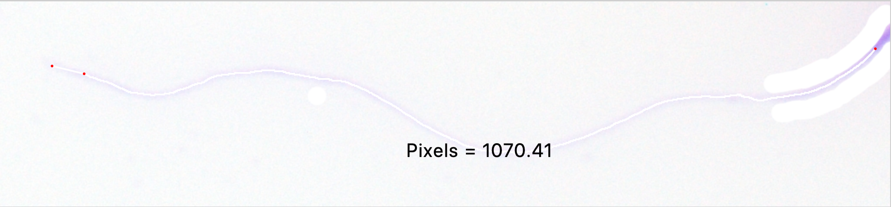

The aim is to remove unnecessary glow, which can be caused even by other cells (see the SpermSizer tracking below, before and after the glow is removed).

 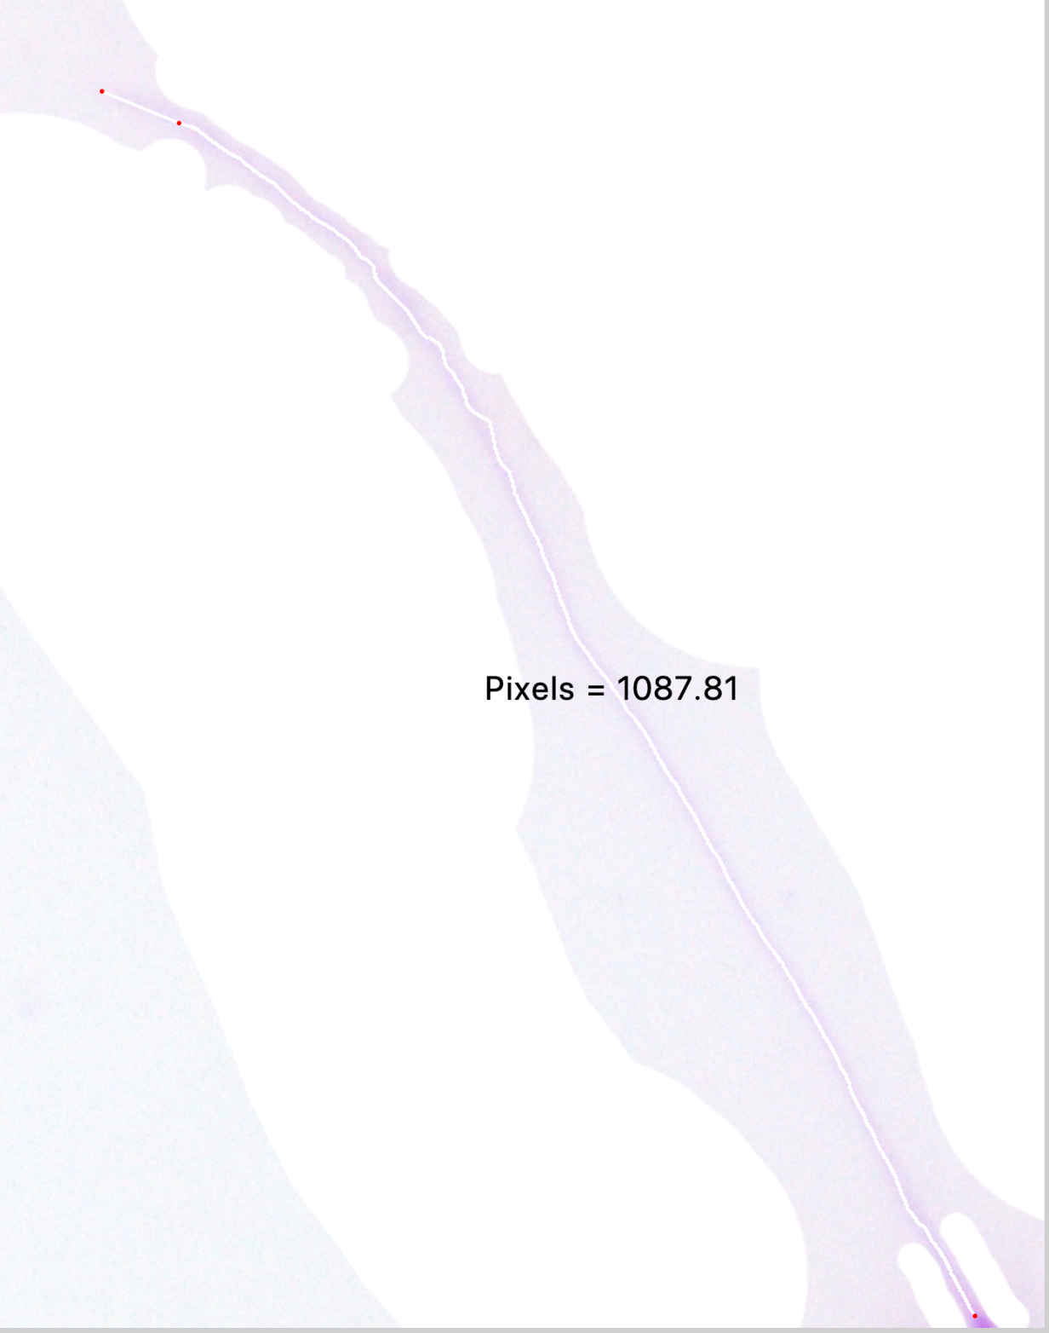

You can use this method to improve the measurements of all other parts as well (e.g. if part of the midpiece is not being picked up because of a dirt nearby).

**EXPORTING THE MEASUREMENTS**

Once you finished measuring, press “Export measurements”, which will save the measurements and pictures of measurements into a folder containing date in its name. Rename the folder by adding your initial (e.g. _MB for Martin Bulla) at the end.